# Question 4

## Part (a)

Monopoly diagram

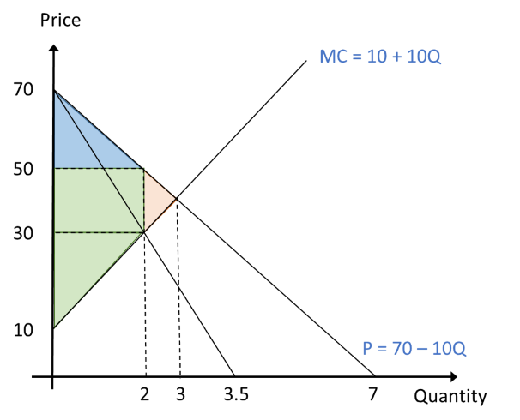

Under monopoly, equilibrium occurs when MR = MC.

Demand: P = 70 – 10Q 🡪 MR = 70 – 20Q

Equate (MR) P = 70 – 20Q with (MC) P = 10 + 10Q

70 – 20Q = 10 + 10Q

30Q = 60

**Q = 2**

Substitute Q = 2 into the demand equation

P = 70 – 10(2)

**P = 50**

## Part (b)

Consumer Surplus = ½ x (70 – 50) x 2 **= 20** (blue shaded area in monopoly diagram)

Producer Surplus = [(50 – 30) x 2] + [½ x (30 – 10) x2] **= 60** (green shaded area in monopoly diagram)

## Part (c)

Deadweight loss = ½ x (50 – 30) x (3 – 2) **= 10**

Deadweight loss is a loss of economic efficiency that occurs when equilibrium for a good or a service is not achieved. In perfect competition, price is determined by the market and firms take the price and only sell it at market equilibrium price. However in monopoly, the monopolist will produce a quantity such that marginal revenue equals to marginal cost. The price charged is based on the demand curve at this quantity.

Deadweight loss tends to be created by monopoly because producer who enjoys a monopoly on the product will charge the price which yields the greatest profit, thereby neglecting the marginal benefit. Monopoly pricing is evident in artificial scarcity, externality, tax or subsidy and other cases. The economic benefit foregone by customers yielding marginal benefit results in the mentioned deadweight loss.

## Part (d)

Disagree. Monopolist will operate at the optimal output where marginal revenue equals to marginal cost (MR = MC) and the price is determined based on the demand curve at the output. Although monopolist has the freedom to set any price it likes, they would need to settle on a price that yields the greatest profit. Setting a maximum price may not necessarily lead to greatest yield.

In contrary, setting the maximum price possible in the market may encourage black market, lead to shortage, queues and eventually become less profitable for the monopoly firms. Hence monopolists are unlikely to only proceed with maximum price without considering other factors. Maximum price is most beneficial in the case where monopolist is both restricting supply and inflating prices. This give the monopolist the absolute deciding power in determining the price to charge.

When setting the price, the monopolist will evaluate the demand for its product and consider the appropriate price such that the production supply and price combination results in maximum economic profit. This is achieved by ensuring that MC = MR at the decided quantity to sell. MR is determined by the demand for the product while MC relates to the cost of production and indicates the increase in economic cost that must occur for an additional unit to be supplied. Hence for monopolist to maximize the total economic profit, it will set the price based on the optimized output where MR = MC and not rely on maximum price only.